- Selecting + Renaming Columns

df = df.select(
col("op_unique_carrier").alias("Airline"),
col("origin").alias("Origin_Airport"),
col("origin_city_name").alias("Origin_City"),
col("origin_state_nm").alias("Origin_State"),
col("dest").alias("Destination_Airport"),
col("dest_city_name").alias("Destination_City"),
col("dest_state_nm").alias("Destination_State"),
col("dep_delay").alias("Departure_Delay"),
col("arr_delay").alias("Arrival_Delay"),
col("cancelled").alias("Cancelled"),
col("month").alias("Month")
)

df = df.dropna()

- Airline code to Airline Mapping

df = df.withColumn(
"Airline_Name",
when(col("Airline") == "9E", "Endeavor Air")
.when(col("Airline") == "AA", "American Airlines")
.when(col("Airline") == "AS", "Alaska Airlines")
.when(col("Airline") == "B6", "JetBlue Airways")
.when(col("Airline") == "DL", "Delta Air Lines")
.when(col("Airline") == "F9", "Frontier Airlines")
.when(col("Airline") == "G4", "Allegiant Air")
.when(col("Airline") == "HA", "Hawaiian Airlines")
.when(col("Airline") == "MQ", "Envoy Air")
.when(col("Airline") == "NK", "Spirit Airlines")
.when(col("Airline") == "OH", "PSA Airlines")
.when(col("Airline") == "OO", "SkyWest Airlines")
.when(col("Airline") == "UA", "United Airlines")
.when(col("Airline") == "WN", "Southwest Airlines")
.when(col("Airline") == "YX", "Republic Airways")
.otherwise("Unknown Carrier")
)
- Average departure by airline

avg_delay = df.groupBy("Airline", "Airline_Name") \
.agg(avg("Departure_Delay").alias("Avg_Departure_Delay")) \
.orderBy("Avg_Departure_Delay")

avg_delay.show(truncate=False)

Output:
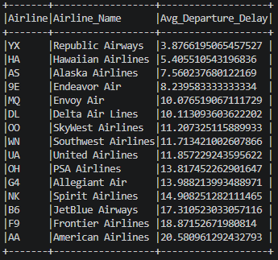

3.Cancellation Rate by Airline
cancel_rate = df.groupBy("Airline", "Airline_Name") \
.agg(avg("Cancelled").alias("Cancellation_Rate")) \
.orderBy("Cancellation_Rate", ascending=False)

cancel_rate.show(truncate=False)

Output:
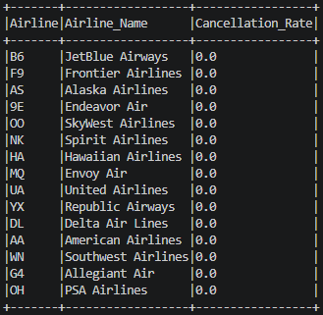

4. Average departure delay by origin airport

delay_airports = df.groupBy("Origin_Airport", "Origin_City", "Origin_State") \
.agg(avg("Departure_Delay").alias("Avg_Delay")) \
.orderBy("Avg_Delay", ascending=False)

delay_airports.show(truncate=False)

Output:
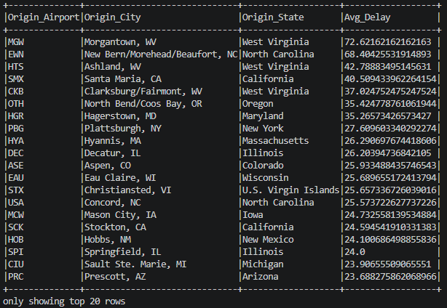

5. Busiest Airports (Most common origin airports by number of flights)
busy_airports = df.groupBy("Origin_Airport", "Origin_City", "Origin_State") \
.agg(count("*").alias("Flight_Count")) \
.orderBy("Flight_Count", ascending=False)

busy_airports.show(truncate=False)

Output:
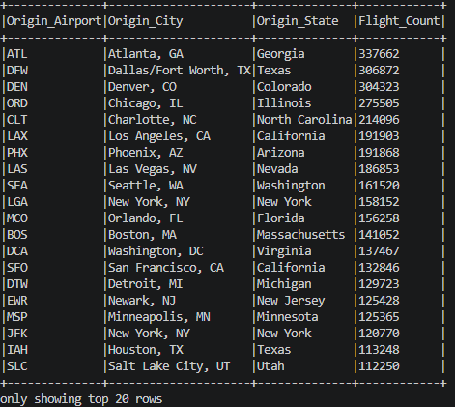\

6. Average departure delay by month
month_delay = df.groupBy("Month") \
.agg(avg("Departure_Delay").alias("Avg_Delay")) \
.orderBy("Month")

month_delay.show()

Output:
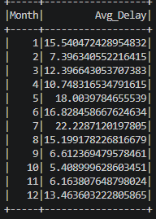

7. Benchmarking airlines based on delay and cancellation metrics
benchmark = avg_delay.join(cancel_rate, ["Airline", "Airline_Name"])
benchmark.show(truncate=False)

Output:

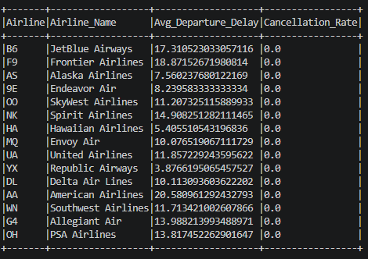

8. Count of Flights with high departure delay (>60 mins) by airline

high_delay = df.filter(col("Departure_Delay") > 60)

high_delay.groupBy("Airline", "Airline_Name") \
.count() \
.orderBy("count", ascending=False) \
.show(truncate=False)

Output:
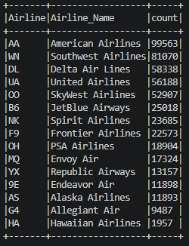

9. Worst performing airlines (Average departure delay and cancellation rate)

worst = benchmark.orderBy(desc("Avg_Departure_Delay"), desc("Cancellation_Rate"))
worst.show(truncate=False)

Output:
